Module 6: Group Assignment
Risk Management

PRABESH RAI | Angelina gochenour | Gladis munoz marin |
heidi schieber | sirona ramahi

ITEC 380: Managing IT Projects
Professor: Jose (Joe) Ascensio

September 29 2025
1.0 Introduction
This document outlines the risk management plan for the University-Wide Print and Projection Upgrade project. The purpose of this plan is to define the methodology, roles, responsibilities, and processes for identifying, analyzing, and responding to potential risks to ensure the project meets its objectives on time and within budget. The ultimate goal of this plan is to ensure the project delivers its success criteria which is completing the upgrade within 60 days, staying within budget, and meeting the University’s standards for functionality and quality.

2.0 Methodology
Risk management will be an ongoing, iterative process performed throughout the 60-day project lifecycle. We will utilize a proactive approach using the following key steps.
- Risk Identification: Continuously identify potential risks by reviewing the Work Breakdown Structure (WBS), Gantt chart, and project scope plans. Team members and stakeholders will be encouraged to report new risks.
- Qualitative Risk Analysis: Verify and analyze the probability and impact of each identified risk.
- Quantitative Risk Analysis: Applied to any required field if needed to analyze the numerical effect of risks on project objectives.
- Risk Response Planning: Develop strategies to address risks, mitigation, transference, or acceptance, including avoidance to eliminate any potential risk.
- Risk Monitoring and Control: Implement the planned responses to track the status of identified risks and monitor for new risks to stay on the project’s track.
In addition, we will use the primary tools and data sources from the project's WBS, Gantt chart, budget and communication management plans, and the expertise of the project team members.
3.0 Roles and Responsibilities
The roles and responsibilities break down the significance of the hierarchy required for effective risk management.
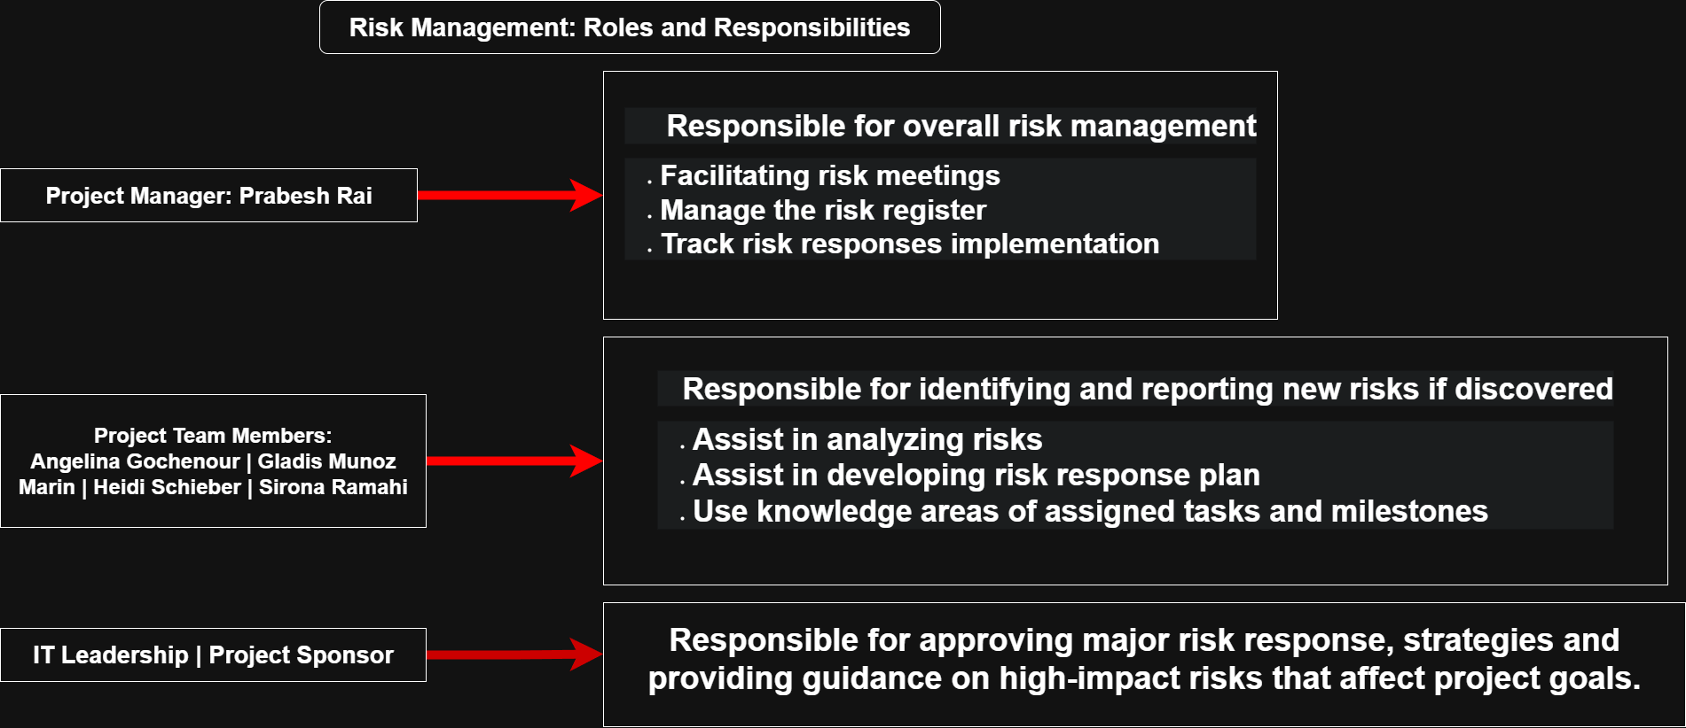
4.0 Budget and Schedule
We will use a specific amount of money and time to manage the risk using budget and schedule knowledge.
Budget:
- Risk Reserve: We have an estimated $40,500 set aside in a 20% contingency reserve.
- Purpose: We will use this money to handle unexpected issues, including supply chain problems, schedule delays, or any operational disruptions, without affecting the main project budget.
Schedule:
- Timeline Focus: The entire project must be completed within 60 days.
- Evaluation: Every time we plan a response to a risk, we need to analyze if it will affect our above timeline to ensure consistency.

5.0 Risk Categories (Risk Breakdown Structure)
We will use the categorized risk breakdown structure (RBS) to ensure comprehensive coverage. It includes all the potential risks related to our project.
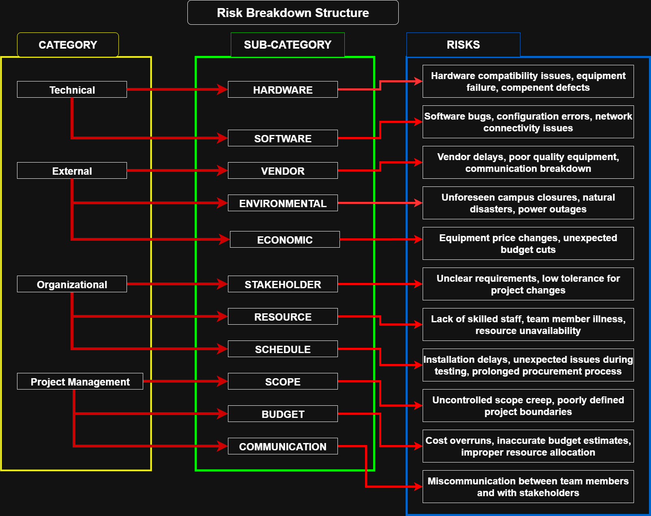
6.0 Risk Probability and Impact
Risk probability and impact will be assessed qualitatively and assigned a score of High, Medium, or Low. The chart shows the two categories with its scores to understand their impact on our project. The probability and impact matrix will be key to prioritizing risks. For example, a risk with High probability and High impact will be our top priority for response planning.

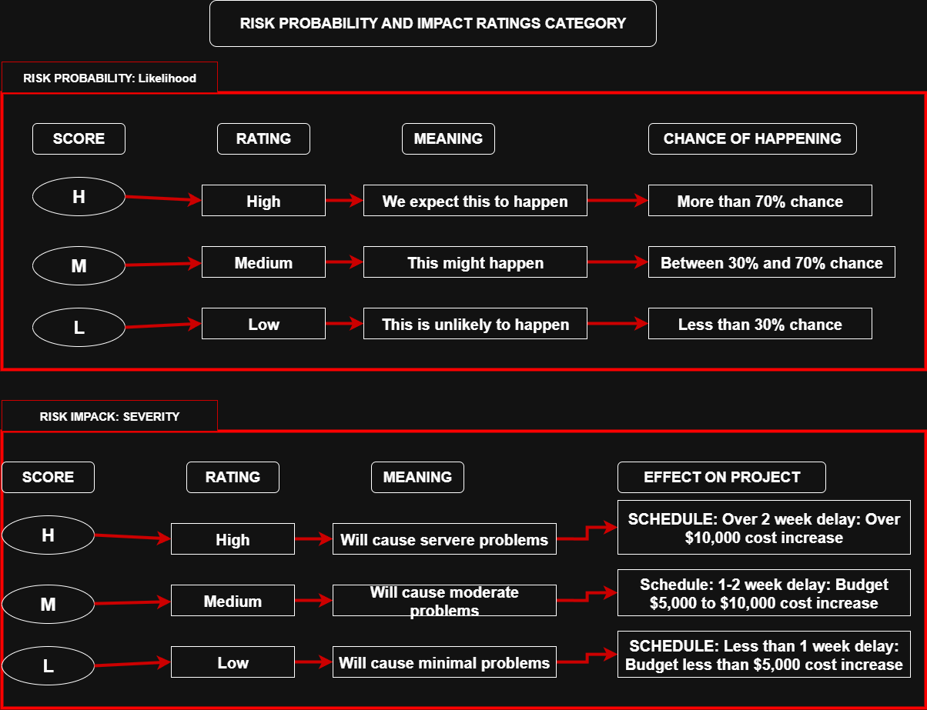

Examples of assessed risk:
Risk Description | Probability | Impact | Priority
Hardware compatibility issues | Medium | High | High
Vendor delivery delays | High | Medium | High
Connectivity issues during testing | Medium | Medium | Medium
Stakeholder miscommunication | Low | High | Medium
Unforeseen campus closure | Low | High | Medium

These identified risks will be entered into the risk register and monitored weekly. The matrix above will be referenced when deciding which risks to respond to proactively.

7.0 Revised Stakeholders’ Tolerances
The project sponsor and IT leadership have a low tolerance for risks that impact the 60-day timeline. Any change requests, as outlined in the Team 1 document, must be approved by IT leadership to ensure changes do not jeopardize the project schedule and overall success. Having this strict control over scope and schedule adjustments will directly influence our risk response planning and make sure everything aligns with stakeholder expectations.
8.0 Tracking
Risk management activities will be tracked and documented to ensure accountability and continuous improvement.
- Weekly Meetings: There will be weekly risk review meetings led by the Project Manager. The status of high-priority risks will be discussed with risk owners providing status updates, mitigation progress, and any new concerns.
- Risk Register: A risk register will be continuously updated to track all identified risks, their probability and impact scores, assigned owners, contingency plans, and current status. Risk information will also be communicated in weekly project status reports to all key stakeholders. Formal risk audits may be scheduled at the mid point of the project to verify that risk processes are being followed correctly.
- Lessons Learned: A lessons learned document will be updated throughout the project to record both successes and failures in risk management for future analysis. The lessons learned document will be documented, shared, and analyzed when the project is concluded.
- Auditing: The Project Manager will conduct informal audits of the risk management process during the weekly meetings to ensure that risk procedures are consistently being followed and accurately documented.
9.0 Risk Documentation
A risk register will be the primary reporting format for risk management activities. The register will be reviewed weekly and updated with the following information:
- Risk ID
- Description
- Category
- Probability and Impact Score
- Risk Owner
- Status (Open, In Progress, Closed)
- Response Strategy
- Contingency Plan
- Current Actions Taken
- Trigger/Event
- Last Updated Date
10.0 Risk Response and Reserves
To manage both identified and unforeseen risks, this project will implement specific response strategies, contingency plans, and reserves.
Risk Response Strategies:
- Avoidance: Changing the project plan to eliminate the risk altogether. Example: selecting only pre-tested hardware to prevent compatibility issues.
- Mitigation: Taking proactive steps to reduce the probability or impact of a risk. Example: ordering equipment well in advance to avoid shipping delays.
- Transference: Shifting the risk to a third party. Example: negotiating vendor contracts with built-in penalties for late delivery.
- Acceptance: Acknowledging the risk and preparing to address it only if it occurs. Example: accepting the risk of minor weather delays without specific action.
In addition, we will use contingency plans for predefined actions if an identified risk occurs. If there are high –impact risks, we will use fallback plans to reduce the risk and contingency reserves to mitigate cost or schedule overruns if known risks occur. For example, if vendor delivery is delayed, the contingency plan will be to place an expedited order with a backup supplier, while the fallback plan will be to adjust the schedule and reallocate resources to other tasks until the equipment arrives. The project team will also monitor for secondary risks, which are risks that may arise as a direct result of implementing these responses, such as increased costs from switching vendors or delays caused by additional testing.

Time Log:
